

Global SAP Application

Maintenance & Support RFP

November 5, 2014

The information contained herein, including the electronic version, is the sole property of Johnson Controls, Inc. It should be treated as both, CONFIDENTIAL AND PROPRIETARY. Through receipt and use of this document, the recipient agrees not to divulge information contained herein to persons other than those with a specific need to know in order to complete the recipient’s response to Johnson Controls, Inc. Recipient also agrees not to use the information in any manner detrimental to the interests of Johnson Controls, Inc. Recipient is authorized to make copies of the paper or electronic version of this document only for the direct purpose of responding to the requests set forth herein.

Contents

1 Executive Summary 5

1.1 Introduction 5

1.2 General Information 7

1.3 About Johnson Controls Inc. 8

1.4 JCI SAP COE Engagement Objectives 9

1.5 Administrative Information 11

1.6 Communication with JCI SAP COE 13

1.7 Notice of Intent to Submit Proposal 14

1.8 The RFP objective 14

2 The RFP Requirements 14

2.1 Scope of Services 14

2.2 Geographies 16

2.3 Application Landscape 16

2.4 Systems in Scope 27

2.5 Support Coverage in Scope 28

2.6 Interface Scope Inclusion 29

2.7 Methodology 29

2.8 Governance 31

2.9 Service Level Metrics 32

2.10 Handover from Projects to support 36

3 Service Level Agreement (SLA) & Key Performance Indicators (KPIs) 38

3.1 SLA Priority Level Table 39

3.2 The RFP Specifications 40

4 RFP Response Requirements 42

4.1 Selection Process Overview 42

4.2 Proposal Format 44

5 Pricing Model 48

5.1 Pricing Requirement 48

5.2 Baseline-Fixed Proposal 48

5.3 Budget Estimate 49

5.4 Creative Proposal 49

6 Contract Information 50

6.1 Proprietary Proposal Material 50

6.2 Notice of Intent to Submit Proposal 50

6.3 Preparation Costs Borne by Vendor 50

6.4 Addenda 50

6.5 Withdrawal of Proposals 50

6.6 Errors in Proposals 50

6.7 Period of Validity of Proposals/Right to Discontinue Process 51

6.8 News Releases 51

6.9 Incorporation of RFP and Proposal in Contract 51

6.10 Prime Contract Responsibility 51

7 Reference Documents 52

7.1 Attachment A – SAP BE interface list 52

7.2 Attachment B – Methodology document 52

7.3 Attachment C – Notice of Intent to Submit Proposal 52

7.4 Attachment D – Financial Proposal Template 52

7.5 Attachment E – RACI Matrix 52

7.1 Attachment F – Resource Plan 52

7.2 Attachment G – Bidders Assumptions 53

7.3 Attachment H – Bidders Questions and Answers 53

Table of Figures

Figure 1 - JCI Organization Structure 8

Figure 2 - Enterprise SAP Center of Excellence (COE) 9

Figure 3 - JCI COE IT – Ops Delivery Structure 10

Figure 4 - RFP Milestones and Dates 12

Figure 5 - JCI-PS Technical Landscape 17

Figure 6 - JCI PS SAP Environment 17

Figure 7 - JCI AE SAP ECC 6.0 Landscape 18

Figure 8 - JCI AE SRM 5.0 Landscape 19

Figure 9 - JCI AE XI Landscape 19

Figure 10 - JCI AE Java stack Landscape 20

Figure 11 - JCI AE BI Landscape 20

Figure 12 - JCI AE Production Landscape 21

Figure 13 - JCI-BE Technical Landscape 24

Figure 14 – JCI - PS applications 25

Figure 15 – JCI AE Genesis Interface Architecture 26

Figure 16 – JCI AE Saturn Interface Architecture 26

Figure 17 – Current JCI SAP COE Governance 31

# Executive Summary

## Introduction

The Enterprise SAP Center of Excellence (COE) of Johnson Controls Incorporated has embarked on an initiative which involves the global roll-out of Global SAP Application Maintenance & Support within the JCI SAP COE IT Operations Pillar.

Johnson Controls Inc. (JCI) has three business units - Automotive Experience (AE), Power Solutions (PS) and Building Efficiency (BE). The Enterprise SAP COE of Johnson Controls (identified throughout this RFP as JCI SAP COE) is consolidating the SAP support of all three units into a single team to leverage the synergies, best practices and to improve the service levels.

This RFP will result in a partnership between the selected Vendors and JCI to create a Global SAP Application Maintenance & Support organization. The integration partners will interact closely with the JCI SAP COE organization, business partners and collaborate with other JCI Support organizations. The integration partners will be expected to complete all assigned deliverables and manage all services to established service-level agreements (SLA’s), and partner agreements. The selected Vendor(s) will work as a partner with JCI SAP COE in the completion of overall deliverables and is expected to participate actively in discussion, planning, and execution of all deliverables.

This Request for Proposal (RFP) is being released to a number of vendors that JCI SAP COE believes can provide the Global AMS services model with implementation/execution expertise and leadership skills to:

* Fully realize the JCI SAP COE vision to set up the Application Support Center of Excellence as an integral part of the COE to improve lifecycle quality, drive cost reduction, reduce time-to-market, and improve portfolio stability while providing an agile and efficient operation.
* Fully implement JCI SAP COE application support best practices, processes in supporting configuration and template control, and SAP side of interfaces to related systems to enable the selling, manufacturing and distribution of Johnson Controls Products. The SAP Application Maintenance & Support will be an outcome driven organization instead of a time-driven organization.
* Provide tools and processes that will enable the JCI SAP COE to successfully absorb additional SAP instance support without linear support cost growth.

As part of the RFP response, each vendor is requested to submit proposals for 2 Packages:

* **Package #1** (Automotive Experience - Genesis/Saturn, Power Solutions - PSES, and Building Efficiency)
* **Package #2** (Automotive Experience: Keiper, Recaro, CRH, and Power Solutions EMEA).

All information unless specifically noted as Package 1 or Package 2 should be considered relevant for both packages.

**Creative Proposal**

JCI is looking for innovative ideas that would prepare the JCI SAP COE to absorb the rapid pace of deployment and scope of Unity with minimum cost growth.

We would like Vendors to provide examples of how your organization and processes will take routine and repeatable support and shift that support from Level 2 to Level 1.5 (Shift Left).

Our expectation is the responder of the RFP will provide innovative, out of box thinking to:

* + Reduce overall baseline support costs, by taking the resolution of issues and shifting left to L1.5 for e.g. First call resolution SLA of 75% +
  + Reduce overall baseline support costs, by providing self – service tools such as password resets and shifting further left to supported user itself
  + Reduce overall baseline support costs, by proactive monitoring for e.g. proactive monitoring of critical business processes and calling out issues to the business users. In this manner the paradigm shifts from Business User creating a ticket to Business User being informed of the problem.
  + Reduce overall baseline support costs, by using tools provided within Solution Manager.
  + Reduce overall baseline support costs by automated resolution of issues.

We also expect that the responder to RFP will provide in the baseline fixed costs / budgeted numbers, the reduction in SLAs on Severity 2, 3 & 4 as options to consider. For example, increased response and resolution times, reduced percentages for Service levels. We are looking for at least two such options. For e.g. if the target is 95 %, then cost out 90 and 85 % targets also.

## General Information

The Vendors should be aware that this proposal will be evaluated in competition with others. The Enquiry documents are prepared and have been compiled to provide an equal opportunity for all Vendors. To obtain a fair evaluation of Vendors, it is essential that all Vendors comply exactly with the instruction and requirements of this RFP. Failure to do so may result in disqualification of the proposal.

Any exceptions/deviations to the RFP shall be stated on a separate chapter. Should the Vendors be in doubt concerning the interpretation of the documents included in the Invitation, or find any discrepancies or omissions, clarification should immediately be sought from Johnson Controls. Any clarification thus provided, if considered to be of any significance, will be issued to all Vendors.

The RFP documents and any addenda there to, are the property of Johnson Controls and are delivered only for the purpose of enabling Vendors to prepare and submit response to this RFP. The information contained in the RFP document and its attachments shall be regarded as confidential and shall not be reproduced in whole or in part or disclosed other than for the purposes of preparing the response. Vendors shall treat all communications in connection therewith as confidential, and shall not disclose any information in connection here with to any third party, other than for the purposes of compiling the response, without the prior approval of Johnson Controls.

The issuance of this RFP does not imply that Johnson Controls is making an offer to do business with any RFP recipient or respondent. No Agreement or other binding obligation on Johnson Controls is implied or will occur unless and until a definitive Services Agreement is executed. The issuance of this RFP and the submission of the Vendors’ proposal do not create any obligation upon Johnson Controls to purchase goods or Services from the Vendors, or to enter into any binding legal relationship with any one or more of the Vendors. Vendors are also advised that Johnson Controls is not bound to accept the lowest or any bid for the performance of the specified Services. Johnson Controls may enter into contracts with more than one Vendor.

Improvement or alternative solutions which can reduce the cost, this should be quoted via an optional recommendations section. All information which in Vendors’ opinion is necessary for Johnson Controls to evaluate the response should be clearly stated therein.

## About Johnson Controls Inc.

Johnson Controls (NYSE: JCI) is a global leader in automotive experience, building efficiency and power solutions. The company provides innovative automotive interiors that help make driving more comfortable, safe and enjoyable. For buildings, it offers products and services that optimize energy use and improve comfort and security. Johnson Controls also provides batteries for automobiles and hybrid-electric vehicles, along with systems engineering and service expertise.

Johnson Controls has 170,000 employees in more than 1,300 locations serving customers in 150 countries. Founded in 1885, the company has its headquarters in Milwaukee, Wisconsin.

* **Automotive Experience:** Global leader in interior systems for light vehicles including passenger cars and light trucks. Systems supplied include seating, overhead, door, instrument panels, storage, and electronics.
* [**Global Work Place Solutions**](http://www.johnsoncontrols.com/content/us/en/about/our_businesses/global-workplace-solutions.html)**:** Leading provider of facilities, corporate real estate and energy management for many of the world’s largest companies.
* [**Power Solutions**](http://www.johnsoncontrols.com/publish/us/en/products/power_solutions.html) **(commonly and hereafter referred to as PS):** World’s largest manufacturer of lead acid automotive batteries and developer of advanced battery chemistries. About 80% of batteries are sold through the automotive aftermarket and 20% are sold as original equipment.
* [**Building Efficiency**](http://www.johnsoncontrols.com/publish/us/en/products/building_efficiency.html)**:** Leading full-line Vendors of mechanical equipment as well as systems that control heating, ventilating, air conditioning (HVAC), lighting, security and fire management in non-residential buildings. Services include complete mechanical and electrical maintenance. World leader in integrated facility management for Fortune 500 companies, managing more than one billion square feet worldwide.

Figure 1 - JCI Organization Structure

Enterprise SAP Center of Excellence (COE)

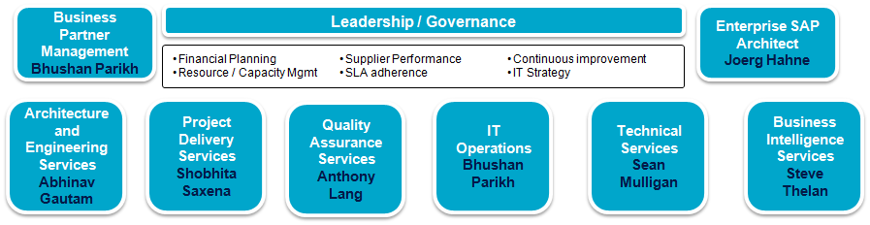

Figure 2 - Enterprise SAP Center of Excellence (COE)

## JCI SAP COE Engagement Objectives

Enterprise SAP COE is requesting proposals from Vendors to assist in establishing the Global SAP Application Maintenance & Support and to deliver responsive, cost-effective and high quality metrics. Selected vendor(s) shall carry out the SAP Application Maintenance & Support (AMS) Services across the globe, for Johnson Controls Inc., Power Solutions (PS-PSES), Automotive Experience (AE-Genesis/Saturn) and Building Efficiency (BE) for various systems and modules through its IT Center of Excellence (COE) considered **Package #1 and Package # 2 (**Keiper, Recaro, CRH, and PS EMEA).

The scope of services will include **SAP Level 1 - L1.5** (Voice, Email, and JCI Incident Management [IM] tool) and **Level 2** - L2 Application Support and Enhancements.

To be clear, this is not an “acquisition model” to take over the Global SAP Application Maintenance & Support. JCI Enterprise SAP COE will still drive the Global SAP Application Maintenance and work collaboratively with the Vendors to provide selected services. JCI Enterprise SAP COE reserves the right to select one or more Vendors for the application support operation.

### JCI COE IT – Ops Delivery Structure

Below figure describes the JCI COE IT – Ops Delivery Structure supported by the current Vendor.

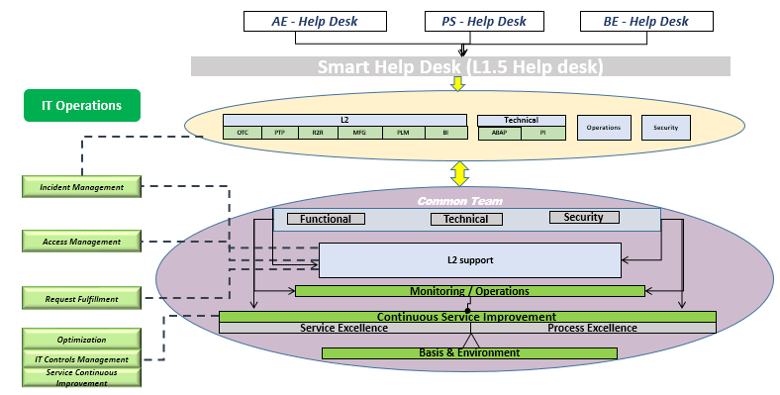

Figure 3 - JCI COE IT – Ops Delivery Structure

Objectives in this engagement will include:

* Vendor needs to be able to provide technical expertise to the JCI User community they serve in regards to applications used to conduct the business.
* Vendor needs to perform application support Level 1.5 and Level 2 against existing SAP applications and new functionality moving into the production landscape.
* Vendor must work within very specific time windows in order to keep parallel integrated developments moving through the landscape.
* Vendor must provide application support within those same time constraints to ensure new project code does not debilitate existing functionality.

Vendor shall carry out the SAP Application Maintenance & Support Services across the locations for various systems and modules as given in the scope.

**The Application Maintenance & Support** engagement aims to:

* Manage the support for the three business units AE, PS and BE under JCI Corporate IT Operations Track.
* Create a comprehensive, global, scalable & integrated Level 1.5, and Level 2 support solution that is aligned with JCI global presence.
* Enforce a Service Framework based upon agreed Services Levels.
* Deliver services that are completely aligned with ITIL framework: Refining the already established Process/Procedures, RACI, for different functions of the SAP Managed Services organization.
* Providing technical expertise, recommendations & guidance around the right model during the multi-year rollout phase.

JCI SAP COE is seeking Vendors input on Best Practice in the context of Organization, Administration and Deployment. Based on your industry knowledge and expertise in providing application support to SAP customers globally, we expect that you will recommend your best practices given your lessons learned, successes, and statistical analysis of similar sized global companies such as JCI.

We anticipate your response will conform to ITIL and Industry best practices, and are supported by evidence of success and your own internal Quality controls. While we seek a highly cost effective solution, we also expect cost effectiveness balanced with user success and high satisfaction ratings.

It is expected of the Vendor to implement the best practices around process and templates, enhance operating model and meet and exceed the performance management set forth in the RFP.

## Administrative Information

### Overview

JCI SAP COE is requesting proposals to acquire responsive, cost-effective and high quality application support services for SAP and other Bolt-on systems and inbound and outbound interfaces.

The primary objective of this RFP is to identify a Vendor that will function as the single (or principal) source Vendor for Level 2 application maintenance services and Level 1.5 Help Desk support. JCI SAP COE has established service levels that it requires, and seeks to identify an outsourcing service provider which can achieve or exceed these service levels and drive down service costs. Additional economies are expected to come from Vendor off-site/shore support capabilities and year on year continuous improvement on the JCI SAP COE account. The scope will include the SAP applications and other bolt-ons as defined further below in this document.

The business drivers and the expected outcome of this RFP are as follows:

### Business Drivers

### Utilization of Best of Class CoE practice

### Reduced costs

### Consistent and improved delivery

### Improved end user satisfaction

### Expected Outcome

**Common Service Level Agreements across:**

* Applications
* Alignment to JCI SAP CoE infrastructure and processes
* Governance

**Consistent Technology Management**

* Reduced incident ticket volume
* Improve application performance
* Consistent ITIL based delivery processes

### Transparency of performance against established targets

### Proactive, real-time and reactive performance reporting

### Root Cause Analysis (RCA) on incidents as part of on-going Problem Management

This RFP is on an accelerated timeline in order to meet the project schedule. **RFP recipients are requested to not include any additional marketing information and that responses strictly adhere to the prescriptive RFP templates provided**. **Additional information volumes beyond what is requested will be viewed as unhelpful.**

### Timeline for RFP Submission and Vendor Selection

The delivery milestones are listed below. Each Vendor is expected to consider these delivery milestones in its response to this RFP. Special consideration will be given to those Vendors that are able to adhere most closely to the original delivery dates.

|  |  |
| --- | --- |
| **Activity** | **Completion or Due Date** |
| NDA and Vendor Invitation to Participate in the RFP | November 3, 2014 |
| RFP released to Vendors | November 5, 2014 |
| Open period for Collaboration (Vendor and JCI) | November 5 - December 4, 2014 |
| Vendor Clarification Calls | November 5 - November 19, 2014 |
| Notice of Intent to Participate | November 14, 2014 |
| Deadline for Vendors’ Questions | November 17, 2014 |
| Vendor Final Conference Call | November 19, 2014 |
| Notice of Intent to Participate | November 20, 2014 |
| RFP Response Due | December 5, 2014 |
| Vendor Oral Presentations in Milwaukee, WI | Week of January 5, 2014 |
| Vendor evaluation, selection & recommendation | January 20, 2015 |

Figure 4 - RFP Milestones and Dates

**Note: Notice of Intent to Submit Proposal is in Attachment C**

### Vendor Proposal Submission

Proposals should be delivered to JCI SAP COE no later than the RFP Response Due Date specified in **Section 1.5.5**. You are solely responsible for ensuring that the proposals are delivered on time. The hard copies should be sent the same day the electronic version is placed in the eRoom for next business day delivery.

Please submit one (1) electronic file in .PDF format to the assigned eRoom (document management portal) and an original plus three (3) copies of the proposal in sealed overnight express packets to:

| Overnight Delivery Service |
| --- |
| Aga Lasota |
| 5757 North Green Bay Avenue, Mail Stop X53 |
| Milwaukee, WI 53209 |
| (414) 524-4475 |

It should be noted that delays caused by any delivery service, including Internet Vendors, the U.S. Postal Service, etc. are not grounds for an extension of the proposal due date and time. Vendors are solely responsible for ensuring that proposals are delivered on time.

Proposals received after the due date and time may, at JCI SAP COE discretion, be rejected unopened.

## Communication with JCI SAP COE

Technical questions will be addressed during the Vendor Conference Call. Please use **Attachment H – Bidders Questions and Answers** and submitper the timeframe in **Section 1.5.5**. Administrative questions and requests for clarification of the RFP scope or Vendor response in connection with this Vendor selection shall be directed to:

Aga Lasota

IT Resource/ Vendor Manager

Johnson Controls – Power Solutions

5757 Green Bay Rd

Milwaukee WI 53209

E-mail: aga.lasota@jci.com

Commercial questions and requests for clarification regarding this RFP should be directed to:

Mr. Fred K Dobrowitsky

Director - IT Procurement Global Commodities

727 Waverly Road

Holland, MI 49423-0000

e-mail: [Fred.Dobrowitsky@jci.com](mailto:Fred.Dobrowitsky@jci.com)

Please note that answers to certain Vendor inquiries may be distributed in writing (E-mail or US Postal) to all Vendors if it is determined that this clarifies JCI SAP COE requirements to all Vendors.

## Notice of Intent to Submit Proposal

Vendors are required to return the “Notice of Intent to Submit Proposal” form contained herein as Attachment C, stating your intention to submit a proposal. This should be submitted electronically to [**Aga.lasota@jci.com**](mailto:Aga.lasota@jci.com). JCI SAP COE will not accept proposals from Vendors that have not submitted a reply form by the date specified in **Section 1.5.5**.

## The RFP objective

* To provide potential vendors with information about the JCI SAP Center of Excellence business and their requirements for fulfilling application support.
* To enable potential vendors to better understand the SAP and related systems landscape as it pertains to the CoE mission to support these applications.
* To provide potential vendors with information about ongoing and planned projects in order to properly bid on services related to application support.
* To provide potential vendors with information on JCI SAP COE expectations and guidelines for their service cost proposals
* To inform potential vendors of the RFP requirements, the vendor selection process, and the rules and expectations around the format/structure of the proposals.
* Establish a common response format for technical, management, and financial proposal responses, to be used by all responding vendors to ensure consistent proposals and to allow efficient and meaningful comparisons between offers.
* To receive a presentation of vendor capabilities that shows how the vendor would staff, govern, measure and report against the CoE application support initiative and provide a comprehensive on-demand suite of services either already identified or suggested by the Vendor in meeting the complete solution for JCI SAP COE needs, encompassing the touch points, hand-offs, and dependencies with project and other CoE tracks.

# The RFP Requirements

## Scope of Services

The AMS scope to support **Package #1** within the JCI SAP COE is:

* Application Services
* Development including ABAP, JAVA, WEB DYMPRO
* Operations monitoring and support
* SAP Help Desk Level 1.5 and Level 2
* Security
* Portal
* Operations and Technical Monitoring
* PI
* BW, BPC, BOBJ
* SRM
* PLM
* CRM
* SNC
* SAC

The AMS scope to support **Package #2** within the JCI SAP COE is:

* Application Services
* Development including ABAP, JAVA, WEB DYMPRO
* Operations monitoring and support
* SAP Help Desk Level 1.5 and Level 2
* Security
* Portal
* Operations and Technical Monitoring
* PI
* BW, BPC, BOBJ
* SRM
* PLM
* CRM
* SNC
* SAC

### Services:

* SAP L1.5 help desk support
* SAP L2 Application support
* SAP L2 Operations monitoring
* L2 Change Requests (In JCI COE: 5100 man hours per month in the first year, 7100 in second year and 9200 for third year. Each CSR/change being under 200 hours).
* L1.5 & L2 Compliance Support. This must include the following:
* L1.5 Compliance – Support Compliance reviews by gathering and providing evidence for audits. Evidence will come from systems that support the provisioning process. This includes SAP and non-SAP systems, such as JCI IM tool, MS Office. Ensure that evidence is provided within Audit expectations (timely & accurate) to support the processes that L1.5 covers. In addition, support and own audit remediation efforts as a result of discovered process deficiencies within L1.5.
* Additionally, L1.5 is accountable for performing an annual review of user access for all SAP users in coordination with Role owners.
* Security – onboarding/off-boarding, passwords, etc…
* Role changes, user admin, CUA setup and management
* L2 Compliance – Support Compliance reviews and initiatives through SAP system configuration / updates, and providing evidence from SAP / Non-SAP systems. Ensure that evidence is provided within Audit expectations (timely & accurate) to support the processes that L2 covers. In addition, support and own audit remediation efforts as a result of discovered process deficiencies within L2.
* Release Management Compliance – All releases (Emergency & Non-Emergency) must comply with documentation and process standards per JCI.
* Operations Compliance – All batch Jobs and Interfaces must be compliant with monitoring and documentation per JCI processes. SOX Compliance for those mitigation activities Vendor is 100% responsible. Adherence to JCI DEV governance policies, including OSS, repairs, development, and development keys

### SAP Applications and Modules in scope

#### Systems in Scope:

* SAP ECC, APO, NFE, FSCM, SRM, SNC, BW, BOBJ, GRC(Access controls and Process Controls),PLM, SolMan, XI/PI, TDMS, Uperform, Centera, Ipoint, EDI, Java Stack, Portals, ADS, PPM, Invoice Approval Tool (Dolphin ), IXOS,CRM, SAC, Taulia, BPC, GRC 10, SARA, Kofax , Taxware and Hyperion Planning. The core SAP modules – FI & CO, SD, CRM, MM, SRM, WM, PP including VC, QM, PS, SNC Security, MHP (JIS/JIT and Complaint Cockpit), and PLM are implemented.

#### Process area and related SAP modules in scope:

* RTR - Financial Accounting (FI), Controlling (CO) and Project Systems (PS)
* OTC - Sales & Distribution (SD), Customer Service (CS) and Customer Relationship Management (CRM), JIT/JIS Processing.
* PTP - Material Management (MM), Supply Chain Management (SCM), Supplier Relationship Management (SRM) and Supplier Network Collaboration (SNC)
* PTD – Production Planning (PP), Warehouse Management (WM), Quality Management (QM), Plant Maintenance (PM) Formerly STP
* PLM – Product Lifecycle Management (PLM – PDM, PLM-PPM, PLM – QM)
* CRM – Customer Relationship Management
* APO – Advance Planning Optimizer
* Security (GRC) – User provisioning, User administration, Security process support, GRC maintenance (CUP workflow, GRC rule set, Firefighter maintenance, Process controls), CUA, Portal Security.
* Portals – PS, Sap Console, Webdynpro ABAP and Webdynpro Java for SAC, SARA and other application portals(SRM,SNC,BI,PLM)

## Geographies

* North America (USA/Canada),
* LATAM (Mexico/Brazil),
* EMEA
* APAC

## Application Landscape

The SAP application landscape that will be supported by selected Vendor(s) is an integral part of the overall landscape of multiple technologies and applications of JCI PS, AE and BE IT systems. The following sections give brief insight into the overall landscape, the global SAP applications landscape and its interface environment with other applications of the IT systems.

### Technical Architecture & Technical Landscape

This section details the technical architecture for SAP systems in JCI for AE, PS and BE units.

**JCI PS:**

The overall technical landscape of JCI PS SAP Applications is represented in the following diagram.

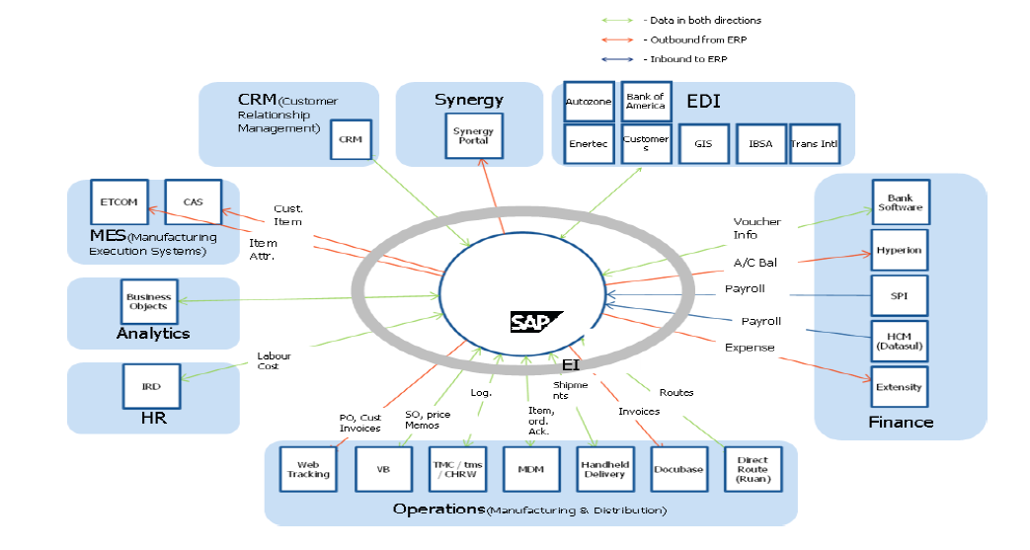

Figure 5 - JCI-PS Technical Landscape

The below diagram (Figure 6) represents the overall SAP architecture of JCI PS that includes technical, application and interface landscape.



Figure 6 - JCI PS SAP Environment

**JCI AE:**

JCI AE has the following landscapes which we would require to be part of the support:

* SAP ECC Landscape
* SAP SRM Landscape
* SAP PI Landscape
* Java stack landscape for SRM / IAT
* SAP BI Landscape
* SAP SAC
* SARA
* Taulia, BPC, GRC 10, Taxware,
* Ixos
* Solution Manager
* TDMS
* NFE

Below is a capture of technical landscapes for non-production SAP ECC and Satellite systems along with the transport path details:

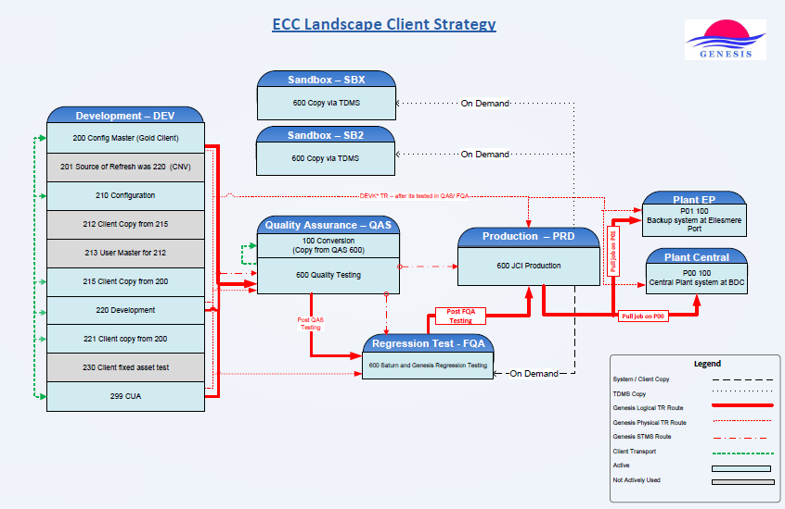

Figure 7 - JCI AE SAP ECC 6.0 Landscape

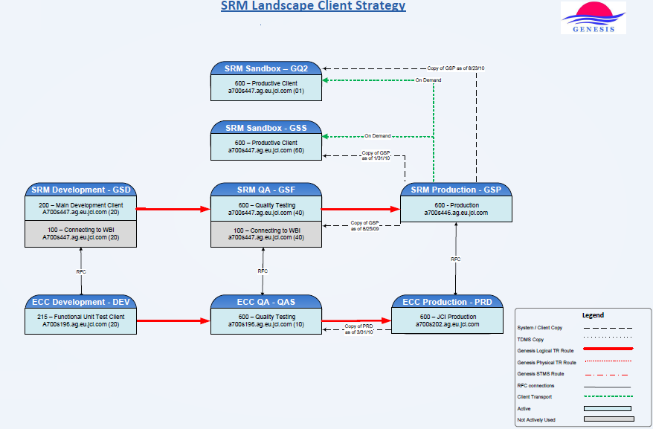

Figure 8 - JCI AE SRM 5.0 Landscape

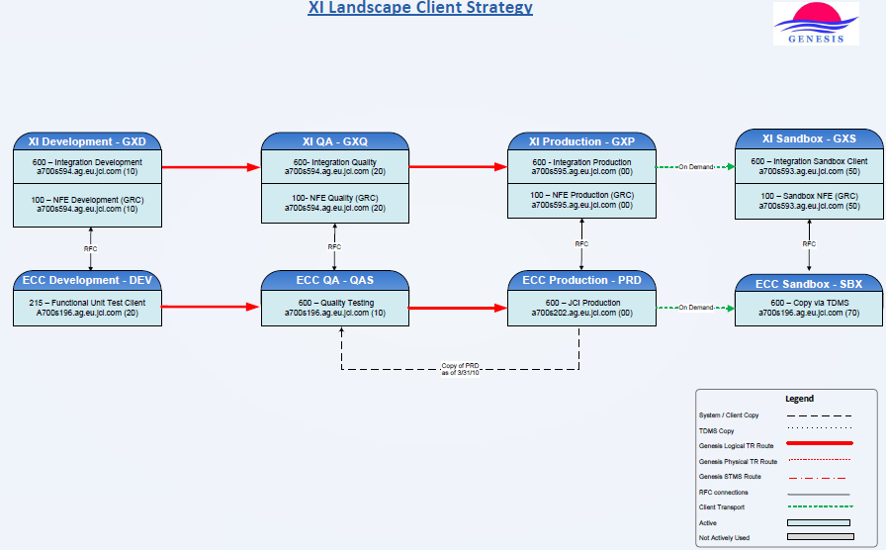

Figure 9 - JCI AE XI Landscape

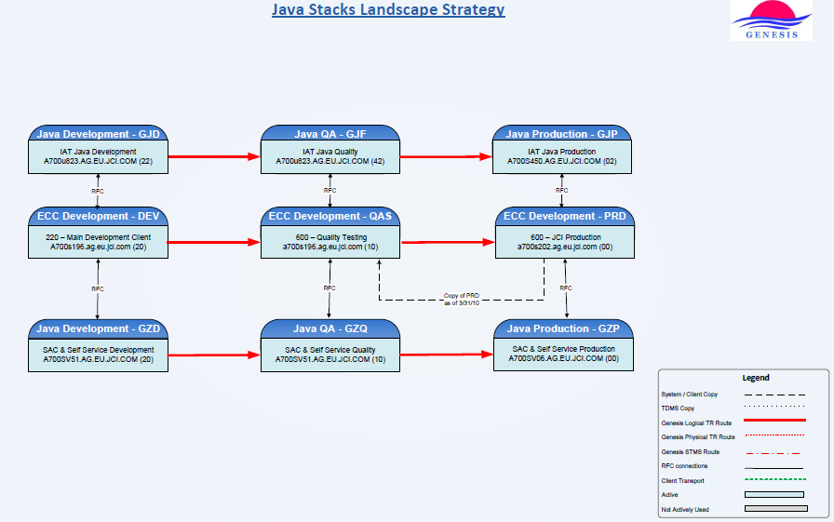

Figure 10 - JCI AE Java stack Landscape

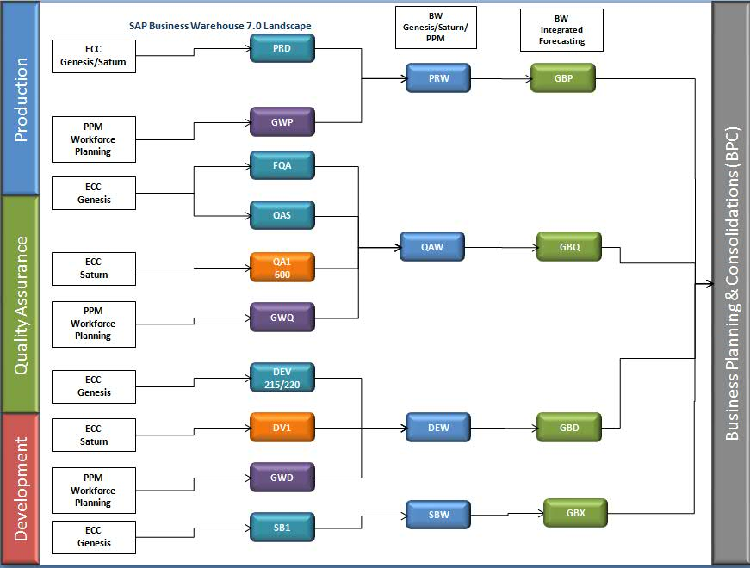

Figure 11 - JCI AE BI Landscape

The SAP application landscape that will be supported by selected Vendor(s) is an integral part of the overall landscape of multiple technologies and applications of JCI AE. The below SAP production landscape gives brief insight into the global SAP applications landscape and interface environment with other applications of the IT systems.

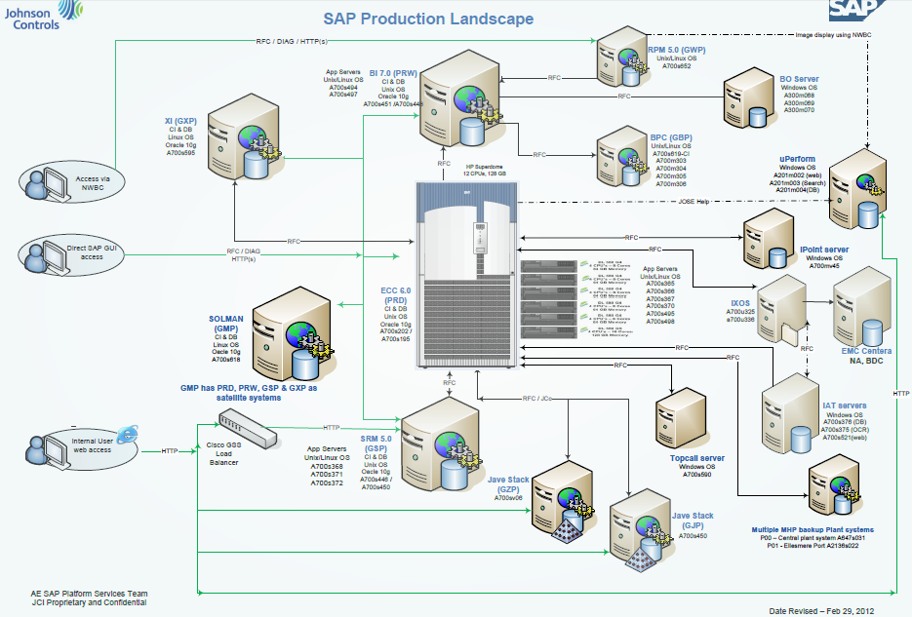

Figure 12 - JCI AE Production Landscape

**JCI BE:**

The SAP application landscape that will be supported by selected Vendor(s) is an integral part of the overall landscape of multiple technologies and applications of JCI BE IT systems.













Figure 13 - JCI-BE Technical Landscape

### Interface Architecture

**JCI PS:**

The following diagram details the various interfaces across the JCI PS applications.

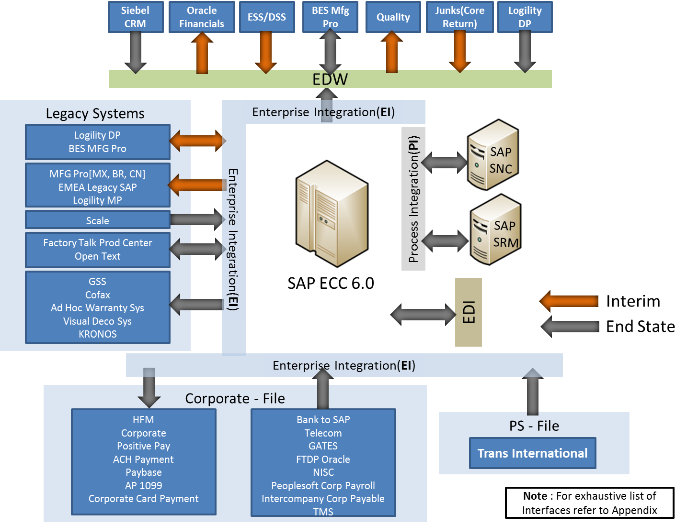

1. JCI PS Interfaces

Figure 14 – JCI - PS applications

**JCI AE:**

The following diagram details the various interfaces across the JCI AE applications.

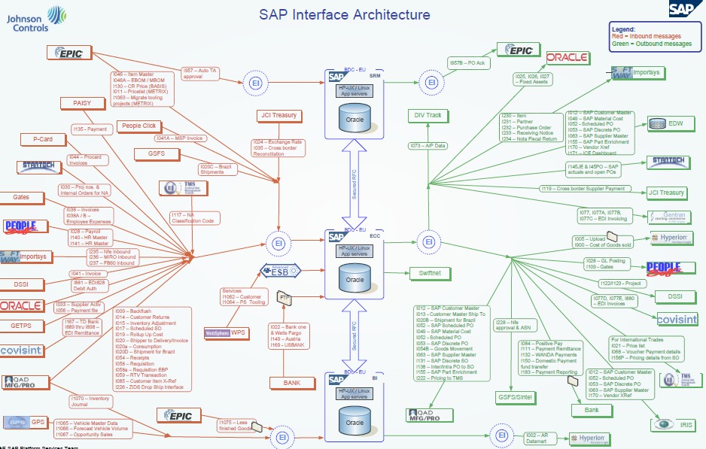

Figure 15 – JCI AE Genesis Interface Architecture

**Saturn Interface Architecture:**

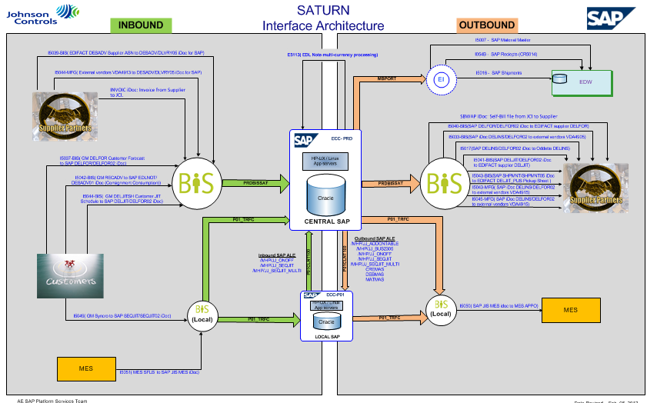

Figure 16 – JCI AE Saturn Interface Architecture

**JCI BE:**

BE Interphase diagram is not available. Please refer to **Attachment C** for the SAP BE interface list.

## Systems in Scope

**Package # 1**

| Details | JCI AE | JCI BE | JCI PS |
| --- | --- | --- | --- |
| Services | SAP Level 1.5 Helpdesk support in English  Level 2 SAP Application support Level 2 SAP Operations monitoring Level 2 Change Requests Level 1.5 & Level 2 Compliance Support. | SAP Level 1.5 Helpdesk support in English  Level 2 SAP Application support Level 2 SAP Operations monitoring Level 2 Change Requests Level 1.5 & Level 2 Compliance Support. | SAP Level 1.5 Helpdesk support in English  Level 2 SAP Application support Level 2 SAP Operations monitoring Level 2 Change Requests Level 1.5 & Level 2 Compliance Support. |
| RTR | ✓ | ✓ | ✓ |
| PTP | ✓ | ✓ | ✓ |
| OTC | ✓ | ✓ | ✓ |
| PTD | ✓ | ✓ | ✓ |
| PPM | ✓ |  | ✓ |
| PLM |  |  | ✓ |
| SRM | ✓ | ✓ | ✓ |
| CRM |  | ✓ |  |
| Security | ✓ | ✓ | ✓ |
| Release | ✓ | ✓ |  |
| Operations | ✓ | ✓ | ✓ |
| PI Support | ✓ | ✓ | ✓ |
| JIS/JIT | ✓ |  |  |
| Portal | ✓ | ✓ |  |
| SAC | ✓ | ✓ |  |
| GRC | ✓ | ✓ | ✓ |
| Regions | North America , LATAM, EMEA, and APAC | North America, LATAM, EMEA and APAC | North America, LATAM , EMEA ,and APAC |

## 

**Package #2:**

| Details | JCI PS EMEA | JCI Keiper and RECARO | JCI CRH |
| --- | --- | --- | --- |
| Services | SAP Level 1.5 Helpdesk support in English  Level 2 SAP Application support Level 2 SAP Operations monitoring Level 2 Change Requests Level 1.5 & Level 2 Compliance Support. | SAP Level 1.5 Helpdesk support in English  Level 2 SAP Application support Level 2 SAP Operations monitoring Level 2 Change Requests Level 1.5 & Level 2 Compliance Support. | SAP Level 1.5 Helpdesk support in English  Level 2 SAP Application support Level 2 SAP Operations monitoring Level 2 Change Requests Level 1.5 & Level 2 Compliance Support. |
| RTR | ✓ | ✓ | ✓ |
| PTP | ✓ | ✓ | ✓ |
| OTC | ✓ | ✓ | ✓ |
| PTD | ✓ | ✓ | ✓ |
| PPM | ✓ | ✓ | ✓ |
| PLM | ✓ |  |  |
| SRM | ✓ | ✓ | ✓ |
| APO | ✓ |  |  |
| Security | ✓ | ✓ | ✓ |
| Release | ✓ | ✓ | ✓ |
| Operations | ✓ | ✓ | ✓ |
| PI Support | ✓ | ✓ | ✓ |
| JIS/JIT |  |  |  |
| Portal |  | ✓ |  |
| SAC |  |  |  |
| GRC | ✓ | ✓ | ✓ |
| Regions | EMEA | EMEA, North America and APAC | EMEA, North America and LATAM |

## Support Coverage in Scope

* **L1.5** is 24*7 On- Seat Coverage:
* **L2** Coverage:
* On Seat support will be provided during week days from Plymouth, Milwaukee, , , Brazil, Bratislava,and other proximity centers as deemed necessary.
* On Call Support: To address urgent and high priority tickets outside the business hours on call support will be provided. Business Users can contact the L1.5 help desk who will provide necessary support in logging the incident and contacting the L2 team if they are unable to provide resolution
* **JIS / JIT support:**
  + JIS/ JIT (Just in Sequence / Just in Time) are special applications implemented in JCI AE for manufacturing activities. These are critical applications and require immediate support to ensure that the manufacturing activities are not impacted.
  + Week days (24 X 5) support to be provided and can be staffed as deemed necessary in the appropriate proximity centers.
* During weekends on call support will be provided for urgent and high priority support.

## Interface Scope Inclusion

* Idoc monitoring (inbound & outbound).
* RFC
* FTP
* ALE/EDI set up and support
* XI NF-e support & message monitoring
* Coordination with 3rd party application
* BDOC
* Flat Files
* Proxy

## Methodology

Vendors must note that JCI uses PM2 methodology for program management. PM2 is the JCI methodology for project management designed to be followed by all JCI Project Managers when managing Projects. Please refer to **Attachment D – Methodology document** for details on PM2 Methodology.

While detailing these deliverables, Vendors is expected to show competence and demonstrated ability in producing deliverables in accordance with their solution implementation methodology while making their best effort to align with the PM2 phases.

In summary, we anticipate your response will conform to ITIL and Industry best practices, and are supported by evidence of success and your own internal Quality controls. While we seek a highly cost effective solution, we also expect cost effectiveness balanced with user success and high satisfaction ratings.

This section details the methodology and the processes to be adopted by Vendor for Steady State support.

|  |  |  |  |  |  |  |
| --- | --- | --- | --- | --- | --- | --- |
| Support Type | Phase | Measurement item | Metrics | Value | Go/No Go criteria | Mitigation/Remarks |
| L1.5 | Knowledge Transfer | Knowledge Transfer Completeness | Helpdesk Call Scripts Completion | Rating on % completion (Completion means validation of Call Scripts by the Vendor AMS team) | 80% | Review of Call Scripts not validated and complete the same within agreed time frame. This will be measured as a ratio of the number of call scripts validated divided by the total number of scripts available |
| L2 |  |  | System Appreciation document Review completion | Rating on % completion (Completion means validation of System appreciation documents by the Project team) | 80% | Review of System appreciation documents not validated and complete the same within agreed time frame |
| L2 |  |  | Knowledge Transfer signoff score | Rating on scale of 1 to 5 | > 3 | Successful reverse Knowledge transfer with rating of above 3 to be achieved latest by 2nd week of Secondary support (Reverse Knowledge transfer Sign off by JCI Business leads and IT leads from JCI CoE- IT Ops team) |
| L2 | Secondary Support | Go-Live Sign off | Business Sign off | Business Sign off for Go-live | 100% | Successful Go-Live of the release to be signed off by business for initiation of Secondary support phase |
| L2 |  | Incident resolution | Resolution % | % of resolution of tickets assigned to Vendor | 75% | Vendor to be integral part of the hyper care team while ownership lies with JCI CoE-IT Ops projects team |
| L2 |  | Implementation Quality | Open critical incidents – Functional | No. of open critical incidents at the time of handover | 0 | If critical open issues exist at the time of hand over, JCI CoE– IT Ops team needs to continue efforts to close the critical incidents |
| L2 |  | Implementation Quality | Open Critical incidents - Data Migration | No. of open critical incidents at the time of handover | 0 | If critical open issues exist at the time of hand over, JCI CoE- IT Ops team needs to continue efforts to close the critical incidents |
| L2 |  | Implementation Quality | Documentation update | All the project documents are completed and signed-off | 100% | JCI CoE- IT Ops Project team will have to complete, obtain signoff and handover the same to the JCI CoE- IT Ops Support team |

## Governance

In addition to providing centralized services, one of the primary responsibilities of the JCI SAP COE is to ensure that the common SAP configuration is maintained, governed and implemented appropriately.

The high-level interaction model of the JCI SAP COE with the current Vendor is outlined below. The Vendor of these services will have to appropriately participate in all related COE functions and communicate with relevant stakeholders as indicated below.

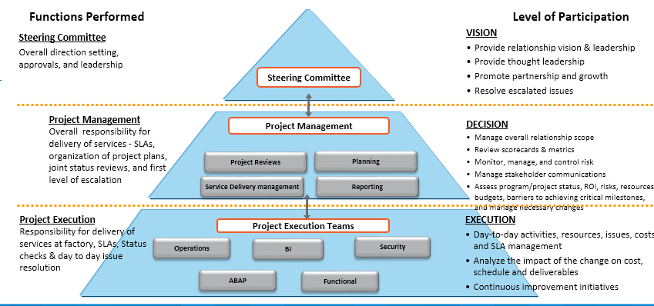

Figure 17 – Current JCI SAP COE Governance

## Service Level Metrics

|  |  |  |  |  |
| --- | --- | --- | --- | --- |
| Service Level | Definitions | Measurement Frequency | Target | Comments |
| L1.5 Resolution | % of tickets resolved in L1.5 | Monthly | 40% | Vendor : this SLA shall be effective after baseline period of each release while Vendor will plan, track and measure SLA from start of steady state |
| L2 Resolution | % of cumulative tickets resolved in L1.5/ L2 | Monthly | 90% | Remaining 10% resolved by L3 team as escalation from L2  Remarks from Vendor  The objective of this metrics is on the % of tickets passed to L3 team 90% resolution of tickets by L2 on a monthly basis will not happen all the time. |
| Acknowledge response time | Response time for tickets based on priority  Urgent- 15 clock minutes*  High - 2 clock hours  Medium - 4 business hours  Low - 2 business days | Monthly | 95% | *Applicable during business hours and on week days. During outside business hours, weekends and holidays – 30 clock minutes. |
| Urgent resolution time | 4 clock hours | Monthly | 95% |  |
| High resolution time | 8 clock hours | Monthly | 95% |  |
| Medium resolution time | 5 business days | Monthly | 95% |  |
| Low resolution time | 10 business days | Monthly | 95% |  |
| CSR Timeliness | CSR's completed on time in the period/Total number of CR's planned for the period | Monthly | 95% | Completion refers to UAT readiness |
| Update documentation | Update documentation after the issue is closed (ticket which does not require a system change) | Monthly | 95% | All times are from ticket closure  Documentation will be updated only for cases where there is no script existing already and the SLA is based on US business hour |
| SOX Compliance Measurement per month | This metric measures the number of Support messages that have failed SOX validation  = Number of Support Messages that have passed through the SOX Validation / Number of Support messages submitted for SOX validation. | Monthly | 95% |  |

Please provide pricing for reduced SLA’s as part of your Creative Proposal.

### Level 1.5 Support

**Execution work flow for L1.5 support is as follows:**

* SAP users may reach Level 1.5 SAP helpdesk team via e-mail, voice calls or logging a ticket in JCI Incident Management Tool ticketing tool to report an incident
* Level 1.5 team shall acknowledge the incident, categorize, prioritize, and log as ticket including receiving calls, logging calls, initial analysis, incident routing, incident tracking, incident escalation, user communication
* Level 1.5 team shall carry out first level of call resolution for all SAP incidents based on Frequently Asked Questions (FAQs) and Knowledge Base documents.
* If the solution is not documented in the Knowledge Base the L1.5 team will route the incidents to the respective Level 2 team (OTC , PTP , etc.,) L1.5 team will update the documentation as part of its continuous improvement of the knowledge database.
* Average call handling time is considered to be 15 minutes for Level 1.5 support team and if not resolved then ticket will be escalated to L2 support team
* If the issue is logged via email or web L1.5 must make every effort to contact the customer via phone first, Lync Chat second and then email. Lync and email communication to be followed up by phone when the customer is reachable.

**Support considerations**

* The support team will provide coverage on all JCI working days globally. The on-site Vendor team members who are working out of JCI locations will follow the JCI Corporate holiday calendar.
* The offshore team will follow the Vendor calendar (applicable to the respective DC’s from where the team works). L1.5 support will be 24 X7. There will be a lean team working during India holidays to support any critical / high priority incidents. JIT/JIS support to be covered regardless of work location holiday schedules.
* Level 1.5 support team will use JCI Incident Management Tool (English only) to log all incidents

**The support window for in-scope languages are listed below:**

* English language calls will be supported on a 24 x 7 ‘On-seat’ basis
* APAC and Madarin language support is required 5x12.
* On-call volume during non-business hours and weekend is forecasted to be 10% of total calls to the L1.5 helpdesk
* Level 1.5 support team during ‘On-call’ should be able to login to JCI network remotely from home laptops only provided to L2 and L1.5 Leads. JCI needs to provide remote connectivity and JCI laptops Vendor will leverage the Knowledge Management tool currently being used by JCI. If it is not available, then Vendor will create Knowledge Base articles in Word documents and upload them in a global wiki portal (to be created).

**Helpdesk with On – Call Support**

**Responsibilities of Level 1.5 Support:**

L1.5. support related key activities are mentioned below for in scope SAP application support:

* Appropriate call classification and assignment
* Log all incidents in JCI Incident Management Tool
* Provide first level resolution of SAP incidents
* Own the call resolution process, including follow-up, communication, escalation, and closure related to tickets owned by L1.5.support team
* Handle SAP user account creation and password resets

Act as a single point of contact for the end users, triage calls, create tickets, and escalate to L2 or EAS (EAS- Engineering And Architecture Services) if required L2 should escalate to EAS.

* Communicate downtime and unexpected activities to JCI CoE- IT Ops and Technical management

Carry out daily, weekly, and other regular reporting activities. This includes L1.5 measurement reporting within timelines as established by JCI

* Provide a representative at operational meetings as necessary
* Maintain JCI SAP L1.5 Helpdesk Handbook containing help desk procedures and working practices, scripts and other documentation including, but not limited to FAQ and KeDb (KeDb- Known error Database)
* L1.5 Compliance – Support Compliance reviews by gathering and providing evidence for audits. Evidence will come from systems that support the provisioning process. This includes SAP and non-SAP systems, such as JCI Incident Management Tools, Microsoft Outlook and SAP systems. Ensure that evidence is provided within Audit (SOX and financial audits) expectations (timely & accurate) to support the processes that L1.5 covers. In addition, support and own audit remediation efforts as a result of discovered process deficiencies within L1.5.
* Additionally, L1.5 is accountable for performing an annual review of user access for all SAP users in coordination with Role owners. In coordination with the Quality Assurance Compliance team.
* Coordinate with the Level 2 team to identify repetitive issues which can be transitioned to the L1.5 team across all tracks. E.g. iDoc error re-processing etc. An example of ‘shift-left” process.

### Level 2 Support

Vendor Level 2 support will be executed in multiple locations to cover regional requirements on completion of planned releases.

Provides extended coverage in USA and India to have seamless hand-offs between onsite and offshore teams.

During non-business hours, weekends, and holidays, there will be on-call support coverage for high priority (Urgent/High) incidents. Level 2 Operations support will have 24 x 7 time zone coverage.

Level 2 support services and related project documentation would be provided primarily in English.

In the case of documentation provided in languages other than English, the Vendor is responsible for maintaining these documents and could engage translation services of a third party company. The costs associated with these translations will be charged back to JCI. Vendor will consult with JCI stakeholders prior to the start of this exercise and get approval on the costs of these services.

**Responsibilities of Level 2 support:**

Level 2 Support will cover only SAP application and associated interface related incidents which are passed on from Level 1.5 team or incidents that are created by business for L2 support Level 2 team will use JCI Incident Management Tool.

The following activities/tasks are part of Level 2 scope:

* Validate and categorize support tickets
* Classify and route enhancement requests to JCI team for CRB (Change Release Board) approval
* Handle break-fix incidents and carry out necessary system changes and workarounds
* Escalate to JCI management any unresolved incidents which require intervention
* Creation of non-project related roles and associated activities (SU24 updates etc.,)
* Provide Roles & Authorizations checks for system changes and minor enhancements as requested by JCI CoE- IT Ops management.
* Identify the system changes required for business process changes ( Configuration changes) and provide the solution to JCI
* Provide solution for minor enhancements requiring less than 200 person-hours of effort per request and based on CRB prioritization and approved by JCI management
* Develop and test system changes and minor enhancements. Test scenario, scripts and data should be provided, validated by Vendor L2 team and approved by JCI management
* Perform Root Cause Analysis 8D (RCA) immediately following the occurrence of a major incident or issue. Root Cause Analysis includes Problem Management, performance tracing, trend analysis, proactive identification of problem areas, and feed back to relevant solution areas and customers
* Provide 24x7 system operation monitoring services as specified in the Application Maintenance Services Support Handbook
* Work collaboratively with other JCI support organizations (Third party support teams) to resolve tickets involving systems interfacing with SAP. Provide complete end to end RCA and issue resolution.
* L2 Compliance – Support Compliance reviews and initiatives through SAP system configuration / updates, and providing evidence from SAP / Non-SAP systems. Ensure that evidence is provided within Audit expectations (timely & accurate) to support the processes that L2 covers. In addition, support and own audit remediation efforts as a result of discovered process deficiencies within L2
* Release Management Compliance – All releases (Emergency & Non-Emergency) must comply with documentation and process standards per JCI
* Operations Compliance – All batch jobs and interfaces must be compliant with monitoring and documentation per JCI standards.
* AMS support team will carry out the system validation testing after every system refresh activities are planned and performed by the JCI environment management team.
* AMS support team will carry out the system validation testing as required for technical patch updates and upgrades that are planned and performed by the JCI environment management team.
* AMS support team will carry out the TDMS data refresh of the ECC clients that are planned by the JCI environment management team
* The AMS team with help from L1.5 team will send reminders to business users with whom tickets are pending for additional information, solution confirmation or closure. If after three such reminders there is no response from the user it will be escalated to respective JCI manager of the ticket caller. The incident will be closed after 5 reminders.

## Handover from Projects to support

JCI CoE-IT Ops team will drive the transition between projects and support, and it governs the entire process. As part of transition from projects to support, the following action items are covered:

* Project teams must provide signed- copies of all Functional / Technical Specifications of the projects to Level 2
* Project team will carry out knowledge sharing sessions on functional and technical changes as documented in Functional Specifications/ Technical Specifications (before integration testing starts)
* Level 2 and JCI COE IT -OPS will run capacity management and adjust the support capacity for knowledge transition, ‘hyper care’/ ‘warranty’ and baseline support period
* Level 2 will shadow tickets/change analysis and resolution during ‘hyper care’/ ‘warranty’ period. Project team will own ticket resolutions during hyper care
* JCI will provide access to relevant document repositories including SAP Solution Manager to organize/conduct training and self-learning programs for Vendor consultants who will be working for JCI
* JCI will extend appropriate licenses for all software tools and applications to Vendor
* JCI will provide access from Vendor offshore premises to all the applications such as SAP instances and bolt-on applications
* For any transition from Project team to Support team, the entry criteria mentioned will be used as a base and the criteria mutually agreed upon.

# Service Level Agreement (SLA) & Key Performance Indicators (KPIs)

The vendor is expected to provide report-outs on SLAs and metrics. JCI SAP COE has identified SLAs and other metrics used as a consistent baseline to assess the critical success factors and risks for the applications within scope of the JCI SAP COE global application landscape. JCI SAP COE is interested in having the Vendor provide other SLAs and metrics based on their experience and best practices.

| **Service Process** | **Purpose / Outcome** |
| --- | --- |
| Incident Management | Receive calls from business users, recording the incident, checking the knowledge data base and providing first call resolution is the responsibility of L1.5 team.  Resolve incidents that are passed by the L1.5 team, as per the agreed SLA’s , document the solution and update business users – by L2 team |
| Problem Management | Permanent correction of underlying problems by performing root-cause analysis (8D) and defect-fix to prevent occurrence of incidents in future – Level 2 Teams |
| Requirements Management | Develop a detailed understanding of requirements of business stakeholders for the applications with respect to minor change requests –Level 2 Teams |
| Change Management | Systemic and methodical implementation of approved changes to the applications to meet business requirements, or to maintain applications health – Mainly minor change requests and the problem management tickets - Level 2 Teams |
| Configuration Management | Tracking and control of all ‘Program and Implementation Guide’ changes (configuration controlled items) until the changes reach production and assess the correctness of the fix in production – Level 2 Teams |
| Release Management | Defining strategy along with JCI team for ‘Movement’ of Level 2 changes from Development system to Production via Quality. This will be handled by release management team |
| Operations Management | Monitoring and fixing any Batch jobs and interface issues and failures. Proactive monitoring of the SAP systems and application health check and performance – Operations monitoring Team, Address early watch report issues |
| Service Continuity Management | Preparedness for rapid restoration and availability of SAP services to business stakeholders in the event of a disaster or special circumstance – The L2 team will coordinate with JCI basis team and other stake holders as required to facilitate this. |
| Security Management | Provide User provisioning and User administration tasks for SAP Systems along with reporting required by compliance team for non-project activity – L2 Team |
| Knowledge Management | Creation of codified knowledge for future re-use, leading to more efficient support services. for both L1.5 and L2. |
| Service Level Management | Ensuring that all incidents are resolved as per agreed SLA’s and other KPI’s are met. |

### Ad-hoc Measurements

Ad-hoc measurements metrics are reported as research is required on a specific incident or problem. Measurements that require trends and analysis are also considered Ad-hoc reporting and will be requested by JCI SAP COE service management as business needs arise.

## SLA Priority Level Table

Priority level means the code used to identify the severity of an issue in an unequivocal manner. The priority levels are described in the following table:

| **Priority Level** | **Description** | **Response Time** | **Resolution Time** |
| --- | --- | --- | --- |
| 1  Urgent | Definition: The complete loss of a critical business service or function for the organization and no alternative is available.  Business and Financial Exposure – Application failure creates critical business operations and major financial impact  Work Outage - The application failure causes the client to be unable to work or perform some significant portion of their job.  Number of Clients Affected – Application failure affects majority of the users | Within 15 minutes | Within 4 clock hours after initial response |
| 2  High | Definition: The partial or limited loss of a critical business service or function and alternative is available.  Business and Financial Exposure – Application failure creates serious impact to business operations and major financial impact  Work Outage – The application failure causes the client to be unable to work or perform small portion of their job at some locations  Number of Clients Affected – Application failure affects some of the users | Within 2 clock hours | Within 8 clock hours after initial response |
| 3  Medium | Definition: Degradation of a critical business service or function but service continues, potential loss of a critical business service, but services continue with a workaround  Business and Financial Exposure – Application failure causes minimum business and financial exposure  Work Outage – The application failure causes the client to be unable to work or perform minor portion of their job and able to complete most of their jobs  Number of Clients Affected – Application failure affects only a few (one or two) users | Within 4 business hours | Within 5 business days |
| 4  Low | Definition: Incidents impacting individual end-user or small groups, an inconvenience to the business  Business and Financial Exposure – Application failure causes no business and no financial exposure  Work Outage – No loss of service  Number of Clients Affected – Application failure affects only a few (one or two) users | Within 2 business days | 10 business days from the Issue Log date. Or planned into the next release (if applicable) |

### Response Times

Response time is measured from ticket creation until the first assignment of a resource to troubleshoot the incident within the respective ticketing system. The time duration between these time stamps are used to effectively measure the response to the end-user. The response time calculation does not imply that the end user has been contacted but an appropriate support resource is reviewing/troubleshooting the incident to provide a corrective plan of action to the end user.

Response time calculation: X amount of tickets responded within Y minutes/hours represented as a percentage

### Resolution time

Resolution time is measured from ticket creation through full restoration of application and individual services. Only when the user confirms successful restoration of services can the user ticket be closed.

## The RFP Specifications

**Staff Selection & Competency**

Vendors will provide, as part of the oral presentation, an individual who may lead this effort. It is recognized that the specific individual may not be available for this engagement but the individual should represent the comparable skills to be expected in the engagement. The Vendors will ensure that all application support staff have appropriate training and possess the requisite skills and experience necessary to deliver high quality work products with reasonable effort.

Staff must be experienced in the JCI tools used in various support roles. The JCI tools in addition to the ones mentioned above:

• HPQC

• Remedy

• uPerform

* Office Suite of products (Excel, Word, etc)

JCI SAP COE reserves the right to approve all Vendors’ associates before they become a billable member of the project team. The Vendors will provide, upon request, a resume and training history for each Vendor associate and will make the associate available for a telephone interview and if possible an onsite or camera interview.

**Staff Retention & Knowledge Transfer**

The Vendors acknowledge that the complexity and on-boarding schedule requires continuity of project staff and agrees to take all reasonable action to minimize staff turnover. The Vendors are responsible for on-boarding and knowledge transfer to replacement staff. The first two (2) weeks of any replacement staff assigned to the project will not be billable to JCI SAP COE.

While JCI SAP COE is looking to select each Vendor to work with over the long-term, they realize that issues could arise and JCI SAP COE could elect to transition this scope of services to another Vendor. The Vendor will proactively participate in all necessary transition efforts in this situation. The Vendor will be paid based upon the on-demand rate card agreed to as part of this project.

**Language**

Due to the extent of the SAP Application Maintenance Services, language and communication skills are an extremely important element that each Vendor needs to bring to the project. Local language is critical for working with the businesses across JCI SAP COE. The official language for all documentation is English.

**Time Zones & Holiday Schedules**

Contractors will observe the JCI SAP COE Holiday schedule as made available and the time zone of record shall be Central Standard Time (Milwaukee, USA).

**Audit & Visitation**

JCI SAP COE reserves the right to audit and approve any Vendor location in advance of the commencement of Application Maintenance services and such approval will not be unreasonably withheld. JCI SAP COE reserves the right to visit and audit all locations where work is being conducted.

**Project Materials & Content Management**

JCI SAP COE will employ the use of various collaboration and document management tools to manage and control the processes, impact analysis, issue management, change requests, progress reporting, source materials, and data associated with supporting the SAP Application Maintenance. JCI SAP COE requires that Vendors will conform to the conventions and business processes prescribed by JCI SAP COE for the management of this material.

The Vendors must also ensure that all processes, impact analysis, issue management, change requests, progress reporting, source materials, and data associated with supporting the SAP Application Maintenance be maintained in the tools provided by JCI SAP COE and that they be maintained in a form that is best suited for future use. For example, documents created with an application like Microsoft Word should be maintained as a Microsoft Word document as opposed to being converted to an Adobe portable document format, PDF, file.

All artifacts, source materials, documents, and data associated with the establishment of the SAP Application Maintenance, including procedures, standards and operating manuals, remain the property of JCI SAP COE and must be provided to JCI SAP COE in electronic form regardless of the completion state of the item.

Attachment E- Methodology Document provides a general description of the current JCI project methodology.

**Thought Leadership**

JCI SAP COE has an expectation that the Vendors’ resources provide skills beyond SAP Application Maintenance requirement delivery. All resources, even the junior-level associates, are expected to think through issues and provide alternative solutions, as appropriate. In addition, all work should be evaluated to determine both the feasibility and the validity of the request. The Vendors should look for opportunities to improve and streamline processes to reduce TCO and increase ROI and present these opportunities to the JCI SAP COE to coordinate with member teams.

As expected in the RFP response, Vendors will provide a model that contains roles and responsibilities for their teams as well as JCI expectations. This should be addressed in Vendors’ model, proposal and rate card.

# RFP Response Requirements

## Selection Process Overview

This Section details the guidelines that JCI SAP COE has established to manage and direct the RFP process. The purpose of these guidelines is to ensure that JCI SAP COE receives proposals that are the result of an open, competitive process, and to ensure that those submitting proposals receive fair and equitable treatment in the solicitation receipt and review of their proposals. JCI SAP COE may reject the proposal of any firm that fails to comply with any of the requirements of this section.

JCI SAP COE evaluation includes reviewing information provided within the proposal, discussions with the vendor, applicable references, and external objective research. It is expected that all responses will be related to JCI SAP COE specific business environment. Generic or “template” responses may result in elimination of the vendor from the selection process. The process is designed to allow JCI SAP COE to select the best vendor.

JCI SAP COE will use a structured process to evaluate all RFP responses, select vendor finalists, and ultimately select the vendor of choice. Many attributes will be evaluated and weighed during the review process. Price is but one of a number of important criteria that must meet the JCI SAP COE requirements. The following list provides some of the factors that will be used to select a vendor. These are not in any specific order and are not all inclusive:

1. Adherence to the RFP guidelines outlined

* Request For Proposal (RFP) accuracy and completeness
* Format of content
* Professionalism of proposal response team
* Concise clear proposal

1. Proposal response and overall solution proposed

* Vendor Solution and Credentials
* Solution design aligned with JCI SAP COE objectives
* Global outcome based delivery capabilities
* Vendor credentials and references
* Ability to create synergies/efficiencies across the JCI SAP COE internal teams, SAP project teams and CoE functions
* JCI SAP COE ability to leverage vendor knowledge/experience with other COEs
* Qualifications/experience with similar AMS outcome based projects of this size
* Qualifications/experience with managing large multiyear projects that cross the globe requiring multi-lingual and cultural sensitivity/knowledge
* Vendor’s knowledge and experience leading managed outcome based global support programs for large business transformations to drive out the business case value
* Risk Management & Quality Control
* Risk management approach
* Execution of quality controls and standards
* Ability to achieve and maintain Service Levels and Metrics
* Technology Integration Experience
* Integration with other applications
* Integration with other tools -SAP Solution Manager, ARIS, TAO, HPQC etc.
* Financial Proposal
* Cost /Rate card
* Price (Total Cost of Ownership (TCO)
* Creative Proposal and Thought Leadership
* Thought leadership with regard to providing alternative solutions
* Risk/reward components relating to schedule/cost/quality compliance and business value and knowledge transfer realization
* Willingness to partner and put skin in the game
* Creativity in alternatives that reduce cost, timeline, risk, and accelerate benefits

**Note:** *We are asking each vendor to critique the proposed approach for ideas on how to streamline the support processes while still ensuring quality, delivery of business value, and an adequate level of risk tolerance.*

The bidding vendors are being asked to participate as follows:

* Preparation of Proposal   
  Each vendor is requested to present a specific proposal in a pre-defined format described in **Section 4.2**. The purpose of this information is for JCI SAP COE to evaluate the vendors on specific topics and to develop an understanding of how the vendor will manage the support process and services. It is expected that the proposals will be supplied no later than the RFP due date so the evaluation team can have adequate time to review the proposal prior to the actual presentation (refer to **Section 1.5.5 Timeline for RFP Submission and Vendor Selection**)
* Vendor Presentation  
  This presentation will allow the JCI SAP COE vendor selection team to meet key vendor personnel that will be part of the global support efforts. JCI SAP COE will evaluate the vendor’s knowledge of the business and software as well as the vendor’s ability to manage the implementation and delivery of the support services. It is expected that the vendor will have available all of the necessary technology, support process and personnel to have a productive and informative session. The vendor presentations will be scheduled within the dates shown in **Section 1.5.5 Timeline for RFP Submission and Vendor Selection**.

**Important Note:** *Vendor presentations will be conducted during the time specified in* ***Section 1.5.5 Timeline for RFP Submission and Vendor Selection****. JCI will provide each Vendor a preliminary date for Vendor presentation. The presentation date for each Vendor will be confirmed or cancelled based on, whether the Vendor demonstrated adequate potential to be awarded this requirement.*

**Important Note:** *Vendors should present their best proposal on or before the date indicated* **Section 1.5.5 Timeline for RFP Submission and Vendor Selection***. JCI SAP COE reserves the right to accept, reject, or award this project, with or without notice, to any vendor, at any time following vendors’ presentations. JCI SAP COE also reserves the right to reassess and negotiate its requirements based on vendor’s responses. While JCI SAP COE will not disclose any vendor’s proprietary information, it reserves the right to set new requirements and pricing targets based on the submissions of the vendors. In addition, vendors’ should take care in the accuracy of their submitted proposals as it is JCI SAP COE intent to materially incorporate their proposals into any final agreement between the parties*.

## Proposal Format

The Vendor proposal must be organized according to the following format and include chapters for each of the following:

|  |  |
| --- | --- |
| **Cover Letter** |  |
| **Executive Summary** | Provide a standalone document entitled “Executive Summary”. The “Executive Summary” shall be written to communicate to a JCI SAP COE executive-level audience and shall contain a succinct (10 pages maximum) summary of the offering, the approach and the value proposition provided by the vendor. The summary should not introduce new information from the proposal, but be an abridged version of the proposal information. The vendor’s value statement should focus on unique items of differentiation that the vendor feels it brings to the table when compared to its competition, as well as a financial summary, focusing on the total cost of ownership. JCI SAP COE will require the vendor to resubmit any response that does not meet this requirement. |
| **Chapter 1**  **Application Support Global Delivery Model and Governance**  **Section 1.1 – Global Delivery Model** | Provide the Vendors Organizational Design and Governance. The model should provide clarity around the following:   * The vendor’s Application support management approach to include the baseline and future activities in scope for this proposal. * Hours of support * Support team locations * Language support * Delivery site coordination   + Detail process flows, touch points, hand-offs, synergies and dependencies that must be established between COE teams, functions and domestic on-shore and off-shore teams   + Detailed work intake process flow for each application support function with the service delivery considerations for future rollouts and countries   + A description of the tools or processes used at each integration point * COE Integration   + Detail process flows, touch points, hand-offs, and dependencies that must be established for all known integration points with JCI SAP COE including organizational entities and tools |
| **Section 1.2 – Transition Methodology** | Provide a plan for transition to your recommended model once selected for the engagement including all key deliverables and estimated time to full functionality for each of the support functions. Show the plan to ramp up and stand up your team from the start of the contract effective date. Explain how risks to continuity of business service and service quality will be addressed during the transition. Consider application area specifics as appropriate. Pricing for transition will be addressed as part of the Financial Proposal. |
| **Section 1.3 – Staffing Approach** | Describe the drivers used to determine head count (example: regional roll-outs, new SAP functionality, new users, etc.)  Describe your method of assimilating JCI support resources into your organization.  Describe how you implement and leverage global and regional staffing and your use of low-cost countries especially:   * Monterrey, MX * Czeska-Lipa, CZ * Bratislava, SK   Describe how you realize year-over-year cost reductions. What are the drivers? |
| **Section 1.4 – Team Organization Chart** | Provide the proposed resource plan for the transition and execution-state for each team. The resource plan should include:   * A listing of roles and responsibilities for each type of program role with details of required experience * An organization chart of the proposed organization at steady-state and the number and role of each resource (e.g. vendor on-site, and vendor off-shore). Describe the resources at ramp-up and their location. Use the template provided with this RFP as Attachment F – Resource Plan. |
| **Section 1.5 - Roles & Responsibilities** | Refer to Attachment E - RACI Matrix provided as a part of this RFP. Based on your understanding of the program requirements, provide a JCI SAP COE and vendor key Roles and Responsibilities Matrix that outlines ownership for all major activities including direct operational activities, project and program management, and governance.  Describe the dependencies outside of your organization and how you manage the dependencies.  Provide a detailed description of each JCI SAP COE role and update the RACI to recommend any changes based on best practices and or to reduce TOC. |
| **Section 1.6 – Service Levels** | Confirm your ability to meet prescribed service levels. Provide any other service levels you think relevant for this program.   * SLAs   + Meeting SLAs defined   + Other SLAs   + Reverse SLAs * Tools and processes used in support of service level reporting and frequency of reporting * Risk/Reward Structure |
| **Chapter 2**  **COE Best Practices** | How does the Vendor intend to incorporate the following:   * Vendors CoE best practices * CoE Maturity model * Reduction in total cost of ownership * Potential areas of cost benefits as maturity of CoE grows in 5 years |
| **Chapter 3**  **Engagement Management**  **Section 3.1 – Scope Management** | Describe your approach to scope management and how you control scope.  Describe how you respond to scope changes and your ability to react to scope through scalability. Specifically address:   * Lead Time * Rate Cards * On-boarding Process * Volume Limits |
| **Section 3.2 – Change Management** | This section refers to change management within projects and working with application changes, not Scope Management. Describe how the team will facilitate manage and direct change control in an outcome based multi-project environment. |
| **Section 3.3– Issue Management** | Describe the methods employed to manage issues. Describe what internal escalation policies, organizational matrices (example: industry experts, performance experts, functional and technical subject-matter-experts, etc.) to minimize the escalation to Level 3. |
| **Section 3.4 – Risk Management** | Describe the risks and challenges you foresee with   * Working in an results engagement * Application transition activities * This particular support initiative   Describe approach used in mitigating risks. Provide RACI diagrams and escalation strategies. |
| **Section 3.5 – Project Communications** | Provide means or methods of communicating with this program and the rest of the JCI SAP COE organization for the proposed off-shore/on-shore model.  Provide details on the standard account review activities such as frequency of meetings and standing topic areas to be addressed including both JCI SAP COE and vendor. |
| **Chapter 4**  **Vendor Capabilities**  **Section 4.1 - Knowledge Coordination, Training and Professional Development** | Describe professional development and training programs for your staff. Describe the support model you will use for orientation of resources assigned to the engagement about the JCI Landscape. |
| **Section 4.2 – Quality Management** | Describe your approach to quality and continuous improvement. Comment on how continuous improvement programs or other initiatives will result in productivity gains over time. Describe in detail current quality initiatives the vendor is working within, and the experience level of quality leaders in your organization. Describe what resources are available to team members to reference and resource quality practices. |
| **Section 4.3 – Methodology & Tools** | Describe your company’s proprietary methodology, tools, and any accelerators that will help ensure success of the Program by delivering quality on budget. |
| **Chapoter 5 – Qualifications & Références**  **Section 5.1 – Qualifications** | Provide concise and specific information on the types of clients served (preferably manufacturing and service clients, size of the organization, yearly sales, and global presence). |
| **Section 5.2 - References** | The Vendor must provide qualified references that will validate the vendor’s ability to work in an outcome based environment which is as similar to JCI as possible. JCI SAP COE prefers references from the auto parts and service industry, manufacturers employing SAP that also engage in an outsourced model for support services. |
| **Appendices**  **Appendix A – Financial Proposal for Package #1 and Package #2** | Please supply the following information as Appendices:  Use RFP Attachment D – Financial Proposal Template |
| **Appendix B – Resource Plan for Package #1 and Package #2** | Use RFP Attachment F – Resource Plan |
| **Appendix C – Staffing Resumes** |  |
| **Appendix D – Additional Vendor Information** | Additional information that supports your proposal. |

**RFP recipients are requested to not include any additional marketing information and that responses strictly adhere to the prescriptive RFP templates that are provided**. **Additional information volumes beyond what is requested will be viewed as unhelpful.**

This format ensures an accurate and consistent evaluation of all proposals by the JCI SAP COE Selection Committee. Failure to submit the proposal in the required format or failure to provide all of the information requested may disqualify your company’s proposal from further consideration.

The Vendors are responsible for providing adequate support documentation to enable a thorough evaluation of the proposal.

# Pricing Model

## Pricing Requirement

JCI SAP COE would like to receive three price proposals – Baseline Fixed, Budget Estimate, and a Creative proposal as described in this section for the application maintenance services in scope for this RFP. Please include any alternative pricing proposals and associated SLA’s as part of the Creative proposal section.

JCI SAP COE is requesting Vendors to provide pricing details for a 3 year term. It is expected that Vendors provide year-over-year productivity and continuous improvements savings.

There will be contract extension reviews at predefined periods of time as mutually agreed upon between the selected Vendors and JCI.

All pricing must be in U.S. dollars. Key assumptions of the financial proposal should be specifically stated. An officer of the Vendor’s company must sign the financial proposal and cover letter. The Vendors are advised that they should present their most favorable solution, pricing, terms and conditions in response to this RFP in order to minimize the time required for negotiations. If mutually beneficial terms cannot be achieved in a timely manner, the next Vendor candidate(s) will be engaged so that the implementation schedule is not compromised.

The Vendors should use the template provided as **Attachment D – Financial Proposal and Resource Template** to submit their pricing. The format of this RFP is intended to evaluate core capabilities that are the most important to JCI SAP COE, therefore, clear concise responses to the RFP is what is being evaluated**, not volume of information provided**. Please adhere to the RFP scope and Forms provided.

In addition, it is likely, that due to business cycle and market conditions, some projects will start sooner and some projected to start and complete later than what is depicted in the release schedule changing the support mix. Therefore, this would be a change in scope and the vendor is not expected to predict that change and bid in that manner; but rather show how

as an organization they anticipate, plan for and react to these types of business fluctuations and the decisions that impact the Global SAP Application Maintenance & Support.

## Baseline-Fixed Proposal

* Bid for all listed baseline scope for this RFP based on the known configuration and RICEFW details provided
* Used to establish a comparative baseline for the engagement
* Use template to provide bid information

**JCI SAP COE** **expects the Vendor to make an investment in time and materials during the Knowledge Transfer phase of this engagement.**

The Vendors are requested to submit Fixed-Bid proposals using internal resources to meet the specific requirements and implementation conditions of projects being supported by the Center Of Excellence. The vendor must show adaptability in the interests of JCI SAP COE where cost, quality, transparency and speed can best be served.

The Baseline-Fixed proposal should reflect the vendor’s resource plan for the transition and execution-state for each Category provided using **Attachment F – Resource Plan**. To be clear, in order to establish a reference point, your Baseline-Fixed proposal must reflect your costs of providing all in-scope services.

## Budget Estimate

* Bid for all listed activities in scope for this RFP based on estimates of the additional scope relative to a baseline of known functionality provided
* Use template to provide bid information

Vendors are requested to provide a Budget Estimate to meet the specific requirements and implementation conditions of the RFP. A Budget Estimate allows for price adjustments based on significant discovery from the previous Baseline-Fixed proposal that JCI SAP COE and the vendor mutually agree to. Budget Estimates will be adjusted to accurately reflect changes in scope. It would then become the vendor’s Baseline-Fixed price. The intent behind this structure is to allow the vendor time within the organization to better understand size and complexity and reflect more accurate pricing.

Furthermore it is the intent that project phases will flow seamlessly regardless of converting a Budget Estimate to a fixed-bid and/or sequencing/overlap of phases. It is the vendor’s responsibility to plan estimate and approval lead times accordingly.

**Note:** *The amount of JCI SAP COE resources identified in this proposal should be considered the maximum resource contribution. Any request to provide resources beyond what has been identified would adversely affect the day to day operations.*

## Creative Proposal

* Must provide Baseline-Fixed and Budget Estimates
* Focus on differentiation from Financial Proposal provided in the RFP
* Must provide detail recommendations for changes to Financial Proposal and predicted benefits and risk
* Adapt template as needed to provide price information

In addition, so long as vendors meet the requirements above, the vendor is requested to propose an alternative Creative proposal that will allow the vendor to differentiate company capabilities in optimizing the project delivery, while focusing on the key issues of cost certainty, commercial transparency, quality, speed and competitiveness. This Creative proposal must demonstrate improvement opportunities referenced against the vendor’s Baseline-Fixed proposal, and provide detail as to how the Creative proposal and approach is better than the Baseline-Fixed proposal.

JCI SAP COE would also like the Vendor to include a proposal that includes the use of vendor-supplied support tools as part of the Creative Proposal. The Vendor Partner should include a detailed description of the application support environment, integration approach to the JCI environment, service levels, and a pricing proposal.

JCI SAP COE will review Creative proposals as one of the subjective criteria used to determine the final selection of Vendor. Creative proposals will be assessed along the following dimensions;

* Detailed understanding of application support requirements
* Specific suggestions and predicted benefits and risk
* Practical, executable nature of proposal (i.e. time compression, impact on JCI SAP COE resources, alternative approach, balance with risk)
* Amount of savings potential as measured against the baseline proposal

JCI SAP COE expects that this aspect of vendor’s proposal will be a significant opportunity for each of the vendors to demonstrate their level of knowledge of this engagement and to convey to JCI SAP COE the benefits of their prior experience in this space.

# Contract Information

## Proprietary Proposal Material

JCI SAP COE will attempt to protect your legitimate trade secrets. Examples of such information would be unpublished descriptions of proprietary aspects of the proposed support solutions. Any proprietary information contained in the proposal must be clearly designated as such and should be separately bound and labeled with the words “Proprietary Information.” Appropriate references to this separately bound information must be made in the body of the proposal.

Except for information or designs that are clearly marked as proprietary to your company, any designs, ideas, and developments that you submit to JCI SAP COE may be used or disclosed by JCI SAP COE. Submission of any such design concepts shall not obligate JCI SAP COE to further contract with your company to produce prototypes, samples, or otherwise purchase any products or services.

Marking all or nearly all of the proposal as proprietary may result in the rejection of the proposal. In this regard, JCI SAP COE may reject any proposal it cannot fairly evaluate if a substantial amount of information is marked proprietary.

## Notice of Intent to Submit Proposal

This section is restated from **Section Error! Reference source not found.**in its entirety. Vendors are required to return the “Notice of Intent to Submit Proposal” form contained herein as [**Attachment C – Notice of Intent to Submit Proposal**](https://eroom2.johnsoncontrols.com/AppData/Local/Temp/Attachment%20F%20-%20Notice%20of%20Intent%20to%20Submit%20Proposal.pdf), stating your intention to submit a proposal. This should be submitted electronically to **Aga.Lasota@jci.com**. JCI SAP COE will not accept proposals from Vendors that have not submitted a reply form by the date specified in **Section 1.5.5.**

## Preparation Costs Borne by Vendor

Any costs associated with preparing proposals and presentations in response to this RFP and for providing any additional information required by JCI SAP COE to facilitate the evaluation process are the sole responsibility of the Vendor and will not be reimbursed by JCI SAP COE.

## Addenda

Changes to this RFP will be made only by formal written addendum (a) issued by the RFP Coordinator.

## Withdrawal of Proposals

Once a Bid is submitted to JCI Enterprise SAP COE a letter of request to withdraw proposal signed by the Vendor is required to withdraw any bid. It is also requested that written notification be provided of intent to withdraw from the selection process anytime throughout the course of selection.

## Errors in Proposals

The Vendor is responsible for errors and omissions in their proposals and any such errors and omissions will not serve to diminish their obligations to JCI SAP COE.

## Period of Validity of Proposals/Right to Discontinue Process

In submitting this bid, the Vendor certifies that the proposal will remain in effect for a minimum period of 120 days from the Proposal Due Date identified in **Section 1.5.5**. JCI SAP COE may request an extension beyond the 120 days. JCI SAP COE also reserves the right to discontinue the procurement process at any time and makes no commitments, implied or otherwise, that this process will result in a business transaction with one or more parties.

## News Releases

Vendors are not permitted to announce involvement in, or release any information to third parties, regarding this procurement. If a Vendor is selected, news releases must be approved by JCI SAP COE prior to any contact with the media.

## Incorporation of RFP and Proposal in Contract

This RFP and the Vendor’s response, including all promises, warranties, commitments, and representations made in the RFP response, shall be binding upon the Vendor and shall be incorporated by reference in JCI SAP COE contract with the Vendor should the Vendor be awarded the contract.

## Prime Contract Responsibility

If Vendor proposal includes hardware, software, or services to be provided by other entities (e.g., project reporting / time tracking), Vendor must nonetheless be able to procure all of the products and services proposed to meet the mandatory specifications. The Vendor must be the sole point of contact for any and all charges resulting from the purchase of the proposed hardware, software, and services for the initial procurement, as well as any additional items proposed to be supplied directly by you.

The Vendor must take full responsibility for the demonstration, delivery, installation, and acceptance of the items you propose to supply directly. The Vendor must also provide maintenance and warranties for its products and pass through warranties of other entities. The Vendor’s proposal must clearly indicate the hardware, software, or services that are not marketed or maintained by your firm. Nonetheless, JCI SAP COE, at its sole discretion, may choose to obtain materials through its own channels.

# Reference Documents

## Attachment A – SAP BE interface list



## Attachment B – Methodology document



## [Attachment C – Notice of Intent to Submit Proposal](https://eroom2.johnsoncontrols.com/AppData/Local/Temp/Attachment%20F%20-%20Notice%20of%20Intent%20to%20Submit%20Proposal.pdf)



## Attachment D – Financial Proposal Template



## Attachment E – RACI Matrix



## Attachment F – Resource Plan



## Attachment G – Bidders Assumptions



## Attachment H – Bidders Questions and Answers

